**1. INTRODUCTION**

**1.1 DEEP LEARNING IN MENTAL WELL-BEING APPLICATIONS**

Deep learning, a transformative subset of machine learning, leverages deep neural networks to tackle complex tasks involving unstructured data such as audio, text, and images. In the context of mental well-being, it empowers systems with advanced capabilities like emotion recognition, user behavior analysis, and personalized content recommendations. Inspired by the multilayered architecture of the human brain, deep learning models can discern subtle emotional cues and cognitive patterns from user inputs—such as voice tone, facial expressions, or textual interactions—enabling more intelligent, empathetic, and adaptive user engagement.In this project, deep learning serves as the foundation for multiple modules, including mood-based yoga pose recommendations, real-time pose detection and correction, and a static chatbot for emotional support. These components utilize deep learning’s strength in automatically extracting meaningful features from raw data, enhancing the system’s ability to respond to individual needs and deliver a personalized mental wellness experience through a web-based interface.

* + 1. **WHY DEEP LEARNING?**

**•** Traditional systems for emotional support or physical wellness recommendations rely on predefined rules or handcrafted features, limiting their adaptability and accuracy. Deep learning addresses this gap by learning complex patterns directly from data. For example, recognizing emotions from user voice or text requires understanding context, tone, and nuance — all of which deep models can capture.

**•** In pose detection and correction, deep architectures like CNNs and PoseNet can identify subtle differences in joint angles and posture without manual calibration. Similarly, in mood detection, deep models can analyze sentiment, affect, and stress levels from user chat inputs or speech. These capabilities allow for real-time, adaptive feedback that enhances the therapeutic impact of the system.

**1.1.2 KEY CONCEPTS**

**•** At the core of this system are artificial neural networks, which consist of multiple layers that progressively transform inputs (like audio signals or pose keypoints) into meaningful outputs (like emotion labels or posture suggestions). Techniques such as backpropagation, dropout, and batch normalization help train these networks effectively while avoiding overfitting.

**•** For tasks like **emotion classification from text or audio**, **Softmax** is often used in the final layer to produce probabilities for different emotional states (e.g., happy, anxious, calm). Optimization techniques like **Adam** and **RMSProp** accelerate learning, while regularization ensures robust generalization.

* + - 1. **ARCHITECTURES USED**

The following deep learning architectures are pivotal to different modules in this project:

**• Convolutional Neural Networks (CNNs)**: Used for detecting and analyzing yoga poses from images or video input. They extract spatial features, such as joint positions and angles.

**• PoseNet**: A pre-trained model for human pose estimation that predicts key body points from real-time camera feeds. It enables feedback on posture correctness and alignment.

**• Long Short-Term Memory (LSTM)**: Applied in mood prediction and user sentiment tracking over time, particularly useful in analyzing text inputs or emotional states from voice patterns.

**•Supportive Models (WaveNet/Transformers)**: Can be explored for future enhancements like generating soothing audio, analyzing tone of voice, or building dynamic conversational agents with contextual memory.

**1.1.4** **ADVANTAGES IN MENTAL WELL-BEING CONTEXT**

**• Adaptive Support**: Learns user behavior over time to offer more relevant recommendations (e.g., calming poses for stress, energizing routines for lethargy).

**• Non-Intrusive Emotion Recognition**: Detects mood from facial expressions, voice, or chat — enabling passive monitoring and support.

**• Personalized Wellness**: Matches users with activities or responses aligned with their emotional needs.

**• Scalable Interventions**: Can support many users simultaneously through automated decision-making and content generation.

* + - 1. **CHALLENGES AND CONSIDERATIONS**

**• Data Sensitivity**: Emotion and mental health data is highly personal; models must prioritize privacy and ethical handling.

**• Interpretability**: Black-box nature of deep learning can make it difficult to explain why a certain suggestion or mood label was given.

**• Real-Time Constraints**: Systems must respond quickly and efficiently, especially when deployed on low-power devices.

**• Noise and Variability**: Audio and video inputs may suffer from environmental noise, poor lighting, or varied accents, which can affect model accuracy.

* 1. **PROJECT OBJECTIVE**

The objective of this project is to develop an interactive web application that promotes both physical and mental well-being. The system offers personalized yoga pose recommendations tailored to the user’s preferences and wellness goals. By leveraging computer vision, it detects and evaluates user poses in real-time, ensuring proper alignment and technique. Machine learning techniques, specifically SVD-based recommendation filtering, are employed to suggest relevant yoga sequences. Additionally, angle-based heuristics are used to provide corrective feedback on poses. To address emotional wellness, the platform integrates a rule-based chatbot that offers supportive, mood-specific interactions. The user-friendly interface enhances accessibility and engagement. Overall, the application serves as a comprehensive wellness companion, aiding users in managing stress and improving their overall health.

## **1.3 PROBLEM STATEMENT**

## Traditional yoga practices often lack the personalized guidance necessary for ensuring correct posture, alignment, and user-specific recommendations, which can lead to inefficiencies or even injury. Furthermore, emotional support systems are typically absent or disconnected from physical wellness platforms, leaving a gap in holistic well-being solutions. This project addresses these challenges by integrating computer vision for real-time pose detection and correction, machine learning for personalized yoga recommendations, and natural language processing to analyze user mood and deliver empathetic chatbot interactions. By combining these technologies, the system offers a unified solution that caters to both physical and emotional aspects of user wellness. It bridges the gap between static instructional content and dynamic, user-centered support, ultimately enhancing safety, engagement, and the overall effectiveness of wellness practices.

## **SCOPE**

## The scope of our project encompasses the development of a comprehensive system for personalized yoga practice and emotional support, integrating various technologies and methodologies. This includes:

1. Mood Assessment: Implementing a mechanism to assess users' emotional states to tailoryoga recommendations and provide appropriate chatbot interactions.

2. Pose Recommendation: Providing personalized recommendations of yoga poses based onthe user's mood input.

3. Pose Detection: Utilizing the YOLO (You Only Look Once) model for accurate detectionof yoga poses from user-uploaded images or videos.

4. Key Features Extraction: Employing the PoseNet model to extract key features of thedetected yoga poses for further analysis.

5. Pose Correction: Implementing an angle heuristic algorithm to provide real-time feedback

and corrective measures for improving the execution of yoga poses.

6. Chatbot Interaction: Developing a chatbot module to interact with users, assess theiremotional states, provide supportive responses, and recommend resources such as YouTube videos.

## **MOTIVATION**

## The motivation behind this project stems from a desire to leverage technology to enhance yoga practice and promote emotional well-being. Traditional yoga methods often lack personalized feedback and guidance, leading to challenges in achieving optimal results and avoiding injuries. Additionally, emotional support is crucial but often not integrated into well-being practices. By combining computer vision, machine learning, and natural language processing, we aim to provide personalized recommendations, real-time feedback, and supportive interactions tailored to individual needs, making yoga practice and emotional support more accessible, effective, and safe for people of all levels

* 1. **PROJECT INTRODUCTION**

In today's fast-paced and digitally-driven world, mental well-being has emerged as a critical component of overall health. The increasing prevalence of stress, anxiety, and other mental health challenges underscores the need for accessible and effective solutions that can seamlessly integrate into individuals' daily lives. Concurrently, the rise of digital health technologies presents unprecedented opportunities to enhance traditional wellness practices through personalization and real-time feedback. It is within this context that the "Interactive Web Application for Mental Well-Being" is conceived—a cutting-edge platform designed to harmonize physical and emotional health through the synergistic integration of personalized yoga practices and an emotion-aware chatbot.

Yoga, a practice revered for its benefits in promoting physical flexibility, strength, and mental tranquility, often relies on consistent guidance to ensure correct posture and technique. Traditional methods, whether conducted in-person or through pre-recorded tutorials, frequently lack the ability to provide individualized feedback, which can lead to inefficiencies and, in some cases, increase the risk of injury. Moreover, while yoga inherently supports mental well-being, the absence of a dedicated emotional support system within these practices limits their potential to address the multifaceted nature of mental health challenges. Addressing these gaps, the proposed web application incorporates advanced technologies such as computer vision, machine learning, and natural language processing to deliver a holistic wellness experience. The platform is divided into two primary modules: the Yoga Module and the Chatbot Module. The Yoga Module leverages the YOLO (You Only Look Once) model for accurate real-time pose detection and PoseNet for extracting key joint features, enabling precise pose analysis and correction through an angle heuristic algorithm. This ensures that users receive immediate, personalized feedback on their yoga practice, enhancing both safety and effectiveness.

Complementing the physical aspect, the Chatbot Module serves as an empathetic companion, engaging users by recognizing and responding to a wide spectrum of emotions. By facilitating conversations that delve into the reasons behind users' emotional states and providing supportive resources such as curated YouTube videos, the chatbot fosters emotional regulation and mental resilience. This dual approach not only personalizes the yoga experience based on users' emotional needs but also offers continuous emotional support, creating a comprehensive tool for holistic well-being.

Furthermore, the application features a user-friendly interface that includes functionalities such as mood assessment, personalized pose recommendations, image upload for pose analysis, and a dashboard for tracking personal progress. Secure user authentication and data management ensure that sensitive information is protected, adhering to stringent privacy standards.

The integration of these sophisticated technologies within a unified platform represents a significant advancement in the realm of digital wellness solutions. By providing tailored physical activity recommendations and robust emotional support, the "Interactive Web Application for Mental Well-Being" empowers individuals to take proactive steps towards maintaining and enhancing their mental and physical health. This innovative approach not only makes yoga practice more accessible and effective for users of all levels but also bridges the gap between physical exercise and emotional well-being, fostering a balanced and healthy lifestyle in an increasingly complex world.

**2.LITERATURE SURVEY**

The literature reviewed spans pose estimation, emotion-aware systems, recommendation algorithms, and chatbot interfaces highlighting foundational works such as PoseNet, YOLOv3, SVD-based recommenders, and affective computing frameworks. These studies collectively inform the multi-modal, user-centered design of *YogaMood Harmony*, integrating AI and wellness for personalized mental and physical guidance

**2.1 RELATED WORK:**

**1. Digital Interventions for Mental Well-Being:**

A growing body of literature highlights the potential of digital platforms to promote mental health and emotional resilience. Early work focused on web-based cognitive behavioral therapy (CBT) modules, chatbots for emotional support, and guided meditation apps (Andersson & Titov, 2014; Fitzpatrick et al., 2017). With the smartphone revolution, mindfulness and stress reduction apps proliferated, enabling users to access mental health resources conveniently (Bakker et al., 2016). More recently, research has explored integrative systems that combine lifestyle adjustments— such as yoga, exercise, and sleep hygiene—with emotional well-being support tools. This body of work suggests that personalizing recommendations based on user mood or stress levels can enhance user adherence and improve mental health outcomes (Mohr et al., 2017).

**2. Pose Estimation and Analysis Techniques:**

The advent of deep learning and computer vision has revolutionized human pose estimation. Earlier approaches primarily relied on handcrafted features and structural models such as pictorial structures. However, with the rise of deep convolutional neural networks (CNNs), pose estimation has seen significant advancements in both accuracy and robustness.Modern models like OpenPose (Cao et al., 2017), MoveNet, and PoseNet (Papandreou et al., 2018; Chen et al., 2022) have been instrumental in identifying human joint keypoints even under varying conditions such as occlusions, lighting variations, and different camera angles. These models have found wide applications in areas like fitness training, sports analytics, and interactive health monitoring systems.In the domain of yoga, pose estimation techniques have been increasingly employed to assess practitioner alignment, detect common postural errors, and provide real-time corrective feedback. Studies by Sharma et al. (2019) and Velloso et al. (2017) demonstrate the utility of pose estimation for yoga by highlighting its potential to support safe, guided practice without the constant need for a human instructor.Furthermore, literature emphasizes the importance of using well-annotated, domain-specific datasets and the need for fine-tuning pre-trained models to ensure accurate performance in specialized tasks such as yoga pose classification and correction.These advancements serve as a strong foundation for our proposed system, which leverages PoseNet for real-time pose estimation and angle-based heuristics for correction in yoga practices.

**3. Recommender System in Wellness and Physical Activity:**

Recommendation engines have traditionally been associated with e-commerce and media platforms, but their application has expanded into the domains of health, fitness, and wellness in recent years (Karimi et al., 2018). Initial health-oriented recommender systems focused mainly on offering personalized nutrition and exercise plans, using techniques like collaborative filtering and content-based filtering to generate advice based on user preferences and historical data.In the specific context of yoga and mental well-being, recent research has highlighted the growing relevance of mood-aware recommendations, where yoga routines are adapted according to a user's emotional or psychological state (Jadhav et al., 2020).

These models aim not only to improve physical health but also to enhance emotional balance and engagement. Hybrid recommendation systems, which integrate user similarities, content features, and contextual data—such as mood, stress level, or time of day have shown improved relevance and personalization compared to traditional methods (Abbas et al., 2022). This aligns with emerging evidence suggesting that contextual personalization, especially when factoring in user mood, can significantly enhance user satisfaction, emotional support, and adherence to wellness practices.These insights form a crucial basis for our project, which integrates SVD-based recommendation and NLP-driven mood analysis to dynamically tailor yoga sessions in a holistic, user-centered manner.

**4. Integrating Pose Correction with Emotional Support:**

While fitness applications and virtual personal trainers have existed for some time, more recent studies look at integrating emotional cues, empathic dialogue systems, and affective computing into these platforms (McDuff et al., 2020). By correlating user mood data with pose recommendations and feedback, research suggests a more holistic approach: users not only receive instructions on correct body alignment but also supportive messages that acknowledge their emotional state. For instance, yoga apps that detect stress or anxiety may adjust the recommended sequence to more calming poses, while simultaneously providing gentle, empathetic guidance. This line of work bridges the gap between purely physical guidance (e.g., posture correction) and psychological support, with literature indicating that multi-modal feedback (verbal, textual, and visual corrections) combined with empathic responses can enhance the user’s overall experience and outcomes (Laamarti et al., 2020).

**5. Gaps, Challenges, and Future Directions**

Despite advances, several gaps remain. First, the availability of large-scale, high-quality yoga pose datasets annotated for both keypoint accuracy and pose difficulty is limited. Most pose estimation models work well on general human activities but struggle with the complexity and variety of yoga postures. Second, integrating emotional states into recommendation systems poses challenges around reliable mood detection and modeling user context without becoming invasive (Calvo & Peters, 2014). Ethical considerations related to data privacy, accuracy of mood inference, and bias in recommendations are highlighted in recent ethics-focused literature (Mittelstadt et al., 2016). Addressing these gaps can guide the next wave of research and application development, enabling more nuanced, context-aware, and ethically grounded yoga recommendation and correction systems that support users’ ultimate well-being and personal growth.

**2.2 LITERATURE SURVEY:**

**Ref. [1]: Liam Kettle and Yi-Ching Lee (2024):**

In their work on digital mental health support, Liam Kettle and Yi-Ching Lee conducted two comprehensive studies examining user interaction with conversational agents specifically designed to enhance well-being. Their research identified critical engagement factors, including empathy, conversational relevance, and usability, as foundational elements that influence user trust and sustained interaction.The findings underscore the importance of designing chatbots with emotional intelligence, enabling them to respond in a manner that aligns with users' psychological and emotional needs. These insights are particularly relevant for applications targeting mental well-being, where human-like understanding and interaction can positively impact user outcomes.Incorporating these principles into our system's NLP-based chatbot ensures that the emotional support provided is not only functional but also empathetic and contextually relevant, thereby contributing to a more holistic user experience.

**Ref. [2]: Dev Kotak, Jay Desai, and Rishi Shah (2022):**

This research presents a yoga pose classification system using Mediapipe’s BlazePose model combined with an angle heuristic approach. The authors successfully implemented a technique that detects 33 keypoints on the human body, enabling precise pose classification for fitness and yoga applications. The use of angle-based evaluation adds a layer of accuracy and practicality to real-time yoga posture assessment, particularly in non instructor settings.

**Ref. [3]: Hema Krishnan and Anagha Jayaraj (2022):**

Krishnan and Jayaraj proposed a machine learning-based model for yoga pose estimation using Mediapipe for keypoint detection. Their study compared several classifiers including SVM and Random Forest to identify the most effective approach for real-time yoga pose classification and correction. The work underlines the importance of combining keypoint extraction with optimal ML algorithms to enhance pose accuracy and personalized guidance in virtual wellness systems.

**Ref. [4]: Pooja Patil and Prof. Sonal Gore (Year Not Specified):**

This study introduced a recommendation system integrating yoga and raga therapy based on Ayurvedic principles. The system tailors suggestions according to users’ prakriti (body constitution), mood, and emotional state, using decision tree and neural network models. By blending traditional health concepts with modern AI techniques, the authors highlight a novel approach to delivering personalized and holistic health recommendations.

**Ref. [5]: Liu, B. (2012)**

This foundational text provides an overview of sentiment analysis techniques and opinion mining strategies in natural language processing (NLP). In your mental well-being application, such methodologies can be directly applied in the chatbot module to analyze and interpret users’ emotional states through their text input. The chatbot to respond empathetically and appropriately, enhancing emotional support through tailored interactions based on detected sentiments such as sadness, stress, or joy.

**Ref. [6]: Miner, A. S. (2016)**

This study evaluates the effectiveness of conversational agents in delivering advice on mental health and related topics. It highlights both the potential and the challenges of using chatbots in health tech applications. For your project, this reference supports the design of the chatbot module, ensuring it offers relevant, context-aware, and sensitive responses to users seeking emotional comfort, helping establish trust and engagement with the digital assistant.

**Ref. [7]: Chen, T., Zhu.L. (2018)**

This paper presents a deep learning-based feedback system that improves yoga posture by analyzing real-time video input. It aligns closely with your system's posture correction module that uses PoseNet and angle-based heuristics to guide users. The findings reinforce the importance of visual feedback loops and posture comparison for achieving safe and effective yoga sessions, supporting your goal of integrating AI to enhance physical well-being alongside mental health.

**Ref. [8]: Dehling, T., & Hofmann, S. (2017)**

Dehling and Hofmann (2017) present a foundational examination of privacy concerns within digital health platforms. Their work highlights how sensitive data, such as mood entries, facial expressions from camera input, and personal conversations through chatbots, require stringent data protection measures. For an application that deals with mental health inputs, their emphasis on transparent data handling and consent mechanisms is especially critical.

**Ref. [9]: Norman, D. A., & Draper, S. W. (1986)**

Norman and Draper’s (1986) work on human-centered design contributes a complementary perspective. They argue for systems that are built around the user’s needs, expectations, and behaviors, rather than forcing users to adapt to the system. Their principles are essential for a health-focused app that users may engage with during vulnerable emotional states. Usability, accessibility, and emotional sensitivity become core design values.

**Ref. [10]: Fitzpatrick, K. K., Darcy, A., & Vierhile, M. (2017)**

In their evaluation of the Woebot chatbot, Fitzpatrick et al. explored how automated conversational agents could deliver cognitive behavioral therapy (CBT) interventions. Through a randomized controlled trial, they found that users engaging with Woebot experienced significant reductions in depression and anxiety symptoms over a short period. This study emphasizes the potential of well-designed AI tools to deliver clinically effective support in accessible, scalable ways.

|  |  |  |  |
| --- | --- | --- | --- |
| **Author** | **Year** | **Title** | **Outcome** |
| Redmon, J. et al. | 2016 | You Only Look Once: Unified, Real-Time Object Detection | Introduced YOLO, a real-time object detection system used for efficient pose detection in visual tasks |
| Wei,S.E.et al. | 2016 | Convolutional Pose Machines | Proposed a deep learning approach for accurate pose estimation, foundational for real-time yoga posture correction. |
| McTear, M. et al. | 2016 | The Conversational Interface: Talking to Smart Devices | Explored the design of intuitive conversationalinterfaces, informing chatbot development for emotional support. |
| Torous, J. et al. | 2016 | New Tools for New Research in Psychiatry | Presented a scalable platform for digital mental health research, highlighting the use of smartphone-based interventions. |
| Kim, J. & Park, Y. | 2020 | Development of a Personalized Yoga Recommendation System Using User Preferences and Posture Analysis | Proposed a hybrid system combining preferences and pose feedback to recommend personalized yoga routines. |

*TABLE 2.1 Literature Survey*

**2.3 PROJECT FLOW**

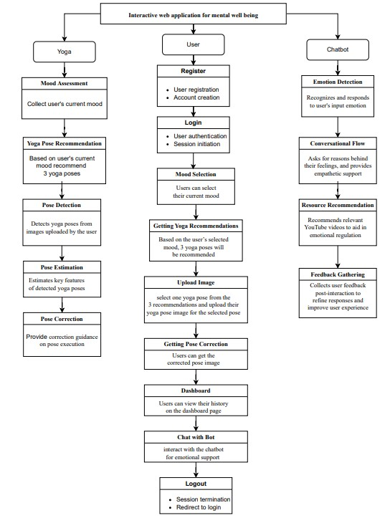

*FIGURE 2.1- Project Flow*

# **3. SYSTEM ANALYSIS**

System Analysis examines the current limitations of existing yoga guidance platforms and explores how the proposed system overcomes these challenges. It evaluates the shift from generic, fragmented solutions to an integrated, intelligent platform offering personalized yoga recommendations, real-time feedback, and emotional support.

**3.1 EXISTING SYSTEM**

Existing methods for personalized yoga practice typically involve manual instruction from yoga teachers or the use of pre-recorded video tutorials, which often lack real- time feedback and personalized guidance. While some online platforms offer algorithm-driven recommendations based on user preferences or

skill level, they do not account for the practitioner's emotional state or provide detailed feedback on pose execution. These methods face challenges in accurately assessing users' emotional states, providing precise feedback on pose alignment, and offering tailored recommendations for individual needs. Moreover, the lack of integration across different technologies results in fragmented user experiences.

* 1. **DISADVANTAGES**

**1.Lack of Personalized Feedback:** Traditional methods often rely on generic instructions, which may not address the specific needs or limitations of individual practitioners.

**2.Risk of Injury:** Without real-time feedback, practitioners may perform poses incorrectly, leading to potential strain or injury.

**3.Inability to Address Emotional States:** Many methods do not consider the practitioner's emotional state when recommending poses or sequences.

**4.Lack of Integration with Advanced Technology:** Existing solutions may not leverage computer vision and machine learning for real-time feedback and personalized guidance.

**5.Fragmented User Experience:** Users may need to utilize multiple platforms for mood assessment, pose recommendations, and instructional content, resulting in a disjointed experience.

**3.3 PROPOSED SYSTEM:**

The proposed system for personalized yoga practice and emotional support addresses these limitations by integrating advanced computer vision, machine learning, and natural language processing techniques. The system includes a mood assessment module to tailor yoga recommendations and chatbot interactions based on users' emotional states. It provides personalized yoga pose recommendations using the YOLO model for pose detection and Pose Net for key features extraction, with an angle heuristic algorithm offering real-time feedback and correction. The chatbot module engages users by recognizing and responding

to various emotions, offering empathetic support and recommending resources. This unified platform, accessible online and via mobile applications, ensures a streamlined and comprehensive experience, promoting enhanced physical and mental well-being through personalized guidance, real-time feedback, and emotional support.

**ADVANTAGES**:

**1. Personalized Guidance:** The system recommends yoga poses tailored to the user's emotional state, providing a more personalized and effective practice experience.

**2. Real-Time Feedback:** Leveraging computer vision and machine learning, the system provides immediate feedback on pose alignment and execution.

**3. Reduced Risk of Injury:** The pose correction algorithm offers detailed guidance to improve pose execution, minimizing the risk of injury.

**4. Enhanced User Experience:** The seamless integration of various technologies ensures a streamlined and comprehensive solution for personalized yoga practice, enhancing user engagement and satisfaction.

**3.4 SYSTEM ARCHITECTURE**

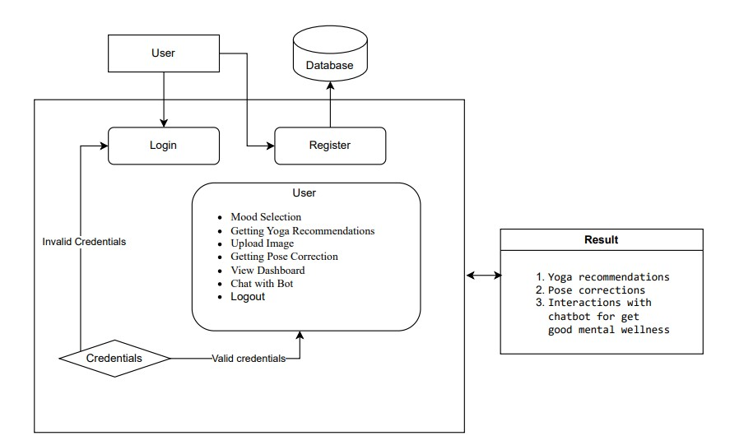

*FIGURE 3.1- System Architecture*

## **4.REQUIREMENTS**

The resources outlined are selected to ensure optimal performance, real-time processing capabilities, and a seamless user experience across all functional modules, including pose detection, emotional analysis, and chatbot interaction.

**4.1 REQUIRED RESOURCES**

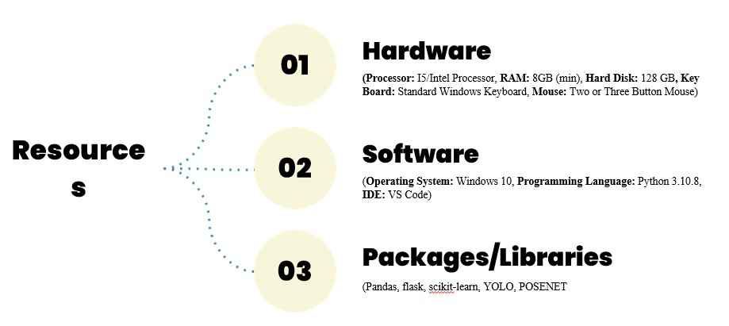

*FIGURE 4.1- Required Resources*

**4.2 SOFTWARE REQUIREMENTS**

Operating System : Windows 10 +

Server-Side Script : HTML, CSS, Bootstrap & JavaScript

Programming Language : Python 3.8+

Libraries : Flask, TensorFlow, PyTorch, OpenCV, NumPy, Pandas,

Scikit-Learn

IDE/Workbench : Visual Studio Code, Jupyter Notebook

Technology : Pose Detection,Recommendation System,Chatbot, YOLO

Server Deployment : Flask / Gunicorn

Database : SQLite / MySQL

**4.2 HARDWARE REQUIREMENTS**

Processor : I3/Intel Processor

RAM : 8GB (min)

Hard Disk : 128 GB

Key Board : Standard Windows Keyboard

Mouse : Two or Three Button Mouse

Monitor : Any

Webcam : Built-in or external HD webcam (for pose detection)

**5. METHODOLOGIES**

This section elaborates on the core methodologies employed—Singular Value Decomposition (SVD) for personalized recommendations, YOLOv3 for real-time pose detection, PoseNet for key feature extraction, and an Angle Heuristic approach for posture correction—ensuring precision, adaptability, and seamless integration across the system architecture**.**

**5.1 SVD FOR RECOMMENDATION SYSTEM**

In the development of YogaMood Harmony, Singular Value Decomposition (SVD) serves as a pivotal component within the recommendation system, embodying a structured methodology and architectural framework.The methodology commences with an exhaustive analysis of user preferences and emotional states, informing the collection of pertinent data comprising user mood inputs and historical yoga practice records. This data undergoes meticulous preprocessing to construct a user-item matrix, where each user's ratings or preferences for specific yoga poses are represented. Subsequently, a robust SVD model is developed, meticulously engineered to decompose the user-item matrix into its constituent components: user factors, item factors, and interaction factors. This intricate decomposition process effectively captures latent features underlying user preferences and yoga poses, fostering a nuanced understanding of the complex dynamics involved. Through rigorous training and optimization, the SVD model is fine-tuned to minimize reconstruction error and enhance predictive accuracy. Leveraging the latent factors extracted through SVD, the recommendation system adeptly generates personalized recommendations tailored to users' historical preferences and current mood inputs. Integration of the SVD-based recommendation system into YogaMood Harmony's architecture ensures seamless interaction with other pivotal modules, including pose detection and real-time feedback mechanisms. This cohesive integration fosters a unified user experience, where personalized recommendations seamlessly complement other facets of the yoga practice journey. Following integration, user feedback plays a pivotal role in refining the recommendation system. Incorporating user insights and assessments regarding recommendation accuracy and relevance enables continuous enhancement of the algorithm, aligning it more closely with users' evolving needs and preferences.

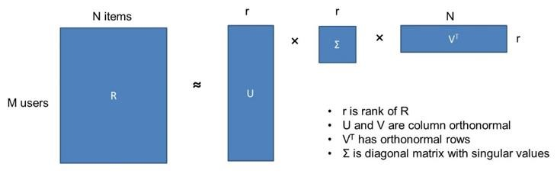

*FIGURE 5.1- SVD For Recommendation System*

**5.2 YOLOv3:**

Yoga Mood Harmony represents a cutting-edge project that seamlessly integrates advanced computer vision techniques with traditional yoga practices. At its core lies a commitment to revolutionizing the yoga experience, enhancing practitioners' wellbeing through personalized guidance and real-time feedback. Central to this endeavor is the utilization of YOLOv3 (You Only Look Once version 3) for yoga pose detection, offering a robust methodology within the project.

Yoga Pose Detection Methodology: The methodology commences with an exhaustive acquisition of a diverse dataset meticulously curated with annotated images or videos showcasing a myriad of yoga poses from varying perspectives. This dataset serves as the foundation for subsequent training, vital for refining the model's proficiency across a spectrum of scenarios. Following dataset acquisition, an intricate preprocessing phase ensues to meticulously refine and prepare the collected data for training. Tasks such as image resizing, pixel value normalization, and data augmentation are meticulously executed to bolster the model's generalization and robustness. Subsequently, the YOLOv3 model architecture is adeptly employed to train a specialized neural network tailored explicitly for yoga pose detection. Renowned for its prowess in object detection, YOLOv3 partitions the input image into a grid and swiftly predicts bounding boxes and class probabilities for each grid cell in a singular pass. Throughout the training process, the YOLOv3 model undergoes iterative refinement, fine-tuning its parameters based on discrepancies between predicted and ground truth annotations to optimize its performance.Post-training, the trained YOLOv3 model seamlessly integrates into the YogaMood Harmony system architecture, synergizing with other modules such as the recommendation system and real-time feedback mechanism. This cohesive integration ensures a holistic user experience, fostering seamless interaction throughout the yoga practice journey. Upon deployment, the YOLOv3-based pose detection module operates in real-time, accurately identifying and localizing yoga poses within live video streams or recorded sessions. This real-time capability empowers practitioners to receive immediate feedback on posture alignment, augmenting the efficacy and safety of their practice sessions significantly. Through the meticulous integration of YOLOv3 for pose detection, YogaMood Harmony endeavors to deliver a transformative platform, harnessing advanced computer vision techniques to enhance the effectiveness and accessibility of yoga practice, ultimately fostering holistic well-being among practitioners.

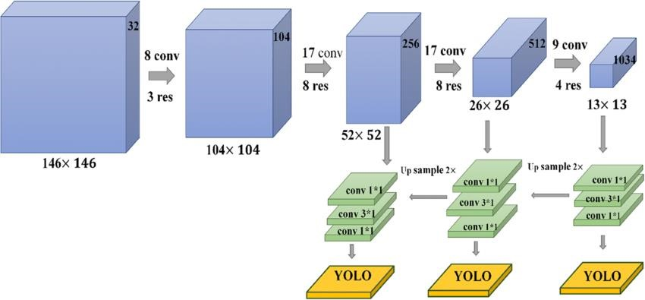

*Figure 5.2- Working of Yolov3*

**5.3 POSENET**

Within Yoga Mood Harmony's innovative framework, the strategic integration of advanced technologies like Pose Net for yoga pose estimation represents a pivotal advancement in personalized wellness solutions. This cutting-edge approach not only revolutionizes the practice of yoga but also empowers practitioners with precise insights into their physical alignment, facilitating tailored guidance to optimize their practice. At the core of this methodology lies the sophisticated algorithms of Pose Net, renowned for their exceptional accuracy in human pose estimation. Through meticulous analysis of input images or video frames, Yoga Mood Harmony leverages Pose Net to discern and precisely estimate the intricate postures adopted by practitioners during their yoga sessions. Beyond mere pose detection, Yoga Mood Harmony goes a step further by extracting key features from the estimated poses. These extracted features encapsulate crucial details about posture angles, body positions, and spatial relationships, providing practitioners with invaluable insights into their practice. Integrated seamlessly into the Yoga Mood Harmony ecosystem, these extracted key features serve as a cornerstone for personalized guidance and feedback. By harmonizing with complementary modules such as mood-based recommendation systems and real-time feedback mechanisms, practitioners benefit from tailored recommendations and immediate feedback aligned with their unique needs and goals. The incorporation of Pose Net and key feature extraction within Yoga Mood Harmony signifies a commitment to advancing holistic wellness through the fusion of technology and tradition. By empowering practitioners with actionable insights and personalized support, Yoga Mood Harmony aims to elevate the yoga experience, fostering a deeper connection between mind, body, and technology in the pursuit of well-being.

This convergence of AI and yoga empowers users with actionable insights, enabling deeper self-awareness and improved alignment throughout their practice. By continuously adapting to posture variations and mood fluctuations, the system delivers meaningful feedback that supports personal growth and sustained engagement. YogaMood Harmony not only enhances the effectiveness of each session but also fosters a more mindful and connected experience, bridging the gap between tradition and innovation. Through this intelligent, adaptive interaction, the platform aspires to elevate the yoga journey—deepening the harmony between mind, body, and technology in the pursuit of mental and emotional balance.

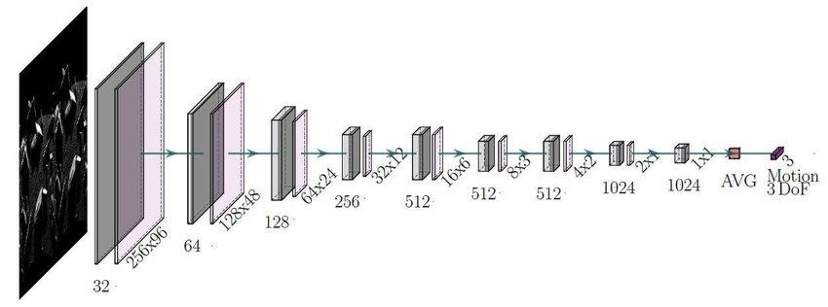

*FIGURE 5.2- Working of Yolov3*

**5.4 ANGLE HEURISTIC**

The angle heuristic method, a cornerstone of the YogaMood Harmony project's pose correction module, is grounded in both traditional yoga principles and modern computer vision techniques. At its core, the method leverages the understanding that proper alignment is fundamental to the effectiveness and safety of yoga practice. By employing computer vision algorithms to detect key points on the user's body during yoga poses, such as joints and anatomical landmarks, the system captures essential data for assessing posture alignment.The method then calculates the angles formed by these key points, drawing from established yoga alignment principles to evaluate the alignment of the pose. Through heuristic rules and thresholds derived from yoga teachings and alignment guidelines, the system interprets these angles to provide real-time feedback to the user. For example, in poses such as downward-facing dog, the angle between the arms, spine, and legs is crucial for maintaining proper alignment and weight distribution. Deviations from optimal angles may indicate areas where posture correction is needed to prevent strain or injury.

Moreover, the angle heuristic method recognizes the individuality of yoga practitioners and their unique anatomical variations. By offering personalized feedback tailored to each user's body and practice level, the system fosters a supportive environment for exploration and growth in yoga practice.Ultimately, this integration of traditional wisdom with cutting-edge technology embodies the YogaMood Harmony project's commitment to promoting holistic wellness through personalized yoga experiences

**5.5 CHATBOT**

**1. Technologies Used**

**Backend**:

• Python: The core programming language used for managing server-side logic, such as processing user input and providing responses based on the predefined dataset.

• Flask: A lightweight Python web framework used to handle HTTP requests, which makes it easy to set up a web application. It connects the backend logic to the frontend interface.

**Frontend**:

• HTML: This is used to structure the chatbot's interface, including text inputs, response display areas, and buttons.

• CSS: It is used for styling the chatbot's interface, ensuring that it looks visually appealing and user-friendly.

• Bootstrap: A popular CSS framework that helps make the chatbot interface responsive, ensuring it adapts well to different screen sizes and devices.

• JavaScript: This is used for managing user interactions, such as receiving user input and updating the displayed conversation dynamically.

Data Handling:

• JSON: The chatbot’s predefined conversational dataset is structured in JSON format. The dataset contains information about various emotions and responses, including comfort messages, follow-up questions, video resources, and feedback responses.

**2. Dataset Analysis**

The dataset is a JSON file that contains information about different emotions. For each emotion, the dataset provides:

• Emotion Name: The name of the emotion (e.g., happy, sad, anxious).

•Follow-up Question: A question that asks the user to provide more information about the emotion they are experiencing (e.g., “What made you feel happy today?”).

• Reasons: Categories that help the chatbot identify the root cause of the emotion (e.g., "work," "relationships," "health").

• Comfort Message: A message that reassures the user and validates their emotional state (e.g., "I’m so glad you’re feeling happy today!").

• Videos: A list of curated video resources related to understanding and coping with the emotion.

• Feedback Question: A question to gauge the user’s state after providing support (e.g., “Do you feel better now?”).

• Positive & Negative Feedback: Responses the chatbot gives based on the user’s feedback (e.g., “That’s great to hear!” or “I understand, let’s try something else.”).

This dataset ensures the chatbot is empathetic and can offer personalized responses to each user based on the emotion they are experiencing.

**3. Backend Development with Flask**

The backend of the chatbot will handle the following tasks:

• Greeting the User: The chatbot starts the conversation with a welcoming message and presents the user with a list of emotions to choose from.

• Emotion Selection: Once the user selects an emotion (e.g., happy, sad), the backend retrieves the relevant information from the dataset.

• Reason Selection: The chatbot then asks the user about the cause of the emotion, based on the predefined reasons in the dataset.

• Comfort Message & Resources: The bot offers a comfort message to the user and provides relevant resources such as videos or articles related to the user’s emotion.

• Feedback Collection: The chatbot asks the user whether they feel better after receiving support and adjusts its responses based on the feedback.

• Closure: The chatbot concludes the interaction by asking if the user would like to continue the conversation or end it.

**4. Frontend Development**

The frontend will display the chatbot interface and manage user interactions:

**•** Chat Interface: The chatbot interface is structured using HTML, where the user can enter their emotions and receive responses from the bot.

• Styling: The interface is styled with CSS and Bootstrap to create a visually appealing and responsive design.

• User Interaction: JavaScript manages user interactions by sending the user's input to the backend (Flask server) and updating the chat window with the responses.

**5. User Interaction Flow**

1. Greeting: When the user first loads the page, the chatbot greets them with a welcoming message and presents a list of emotions for the user to choose from (e.g., "Happy," "Sad," "Anxious").
2. Emotion Selection: After selecting an emotion, the chatbot asks a follow-up question (e.g., “What made you feel happy today?”). The user then provides a reason for their emotion (e.g., "I had a good day at work").
3. Comfort Message & Resources: Based on the emotion and the reason, the chatbot offers a comforting message (e.g., “It’s great that you’re feeling happy!”) and shares relevant resources like videos or articles to help the user cope with or further explore their emotions.
4. Feedback: The chatbot asks the user how they feel after the conversation (e.g., “Do you feel better now?”). Depending on the user's response (positive or negative), the chatbot responds accordingly with either encouragement or further support (e.g., "I'm happy you're feeling better!" or "It's okay, let's try something else").

**6. Final Thoughts**

The chatbot is designed to be both empathetic and resourceful, guiding users through their emotions with personalized feedback and offering helpful resources to improve their emotional well-being. This project combines frontend and backend development to create an interactive, supportive experience for users.The use of a static dataset ensures that the chatbot can handle common emotions and responses, while the backend logic (powered by Flask) allows for seamless interactions with the user. With real-time feedback, comforting responses, and curated resources, the chatbot aims to provide an engaging and supportive experience that can help users feel heard and understood.

## **6. SYSTEM DESIGN**

This phase translates the system requirements into a structured model that guides the implementation of both functional and non-functional components. The design process emphasizes modularity, scalability, and ease of use, ensuring the integration of various technologies—pose detection, recommendation engines, chatbots, and feedback mechanisms—into a cohesive platform.

**6.1 INTRODUCTION OF INPUT DESIGN:**

Input design focuses on how user data enters the system, ensuring accuracy, efficiency, and user-friendliness. For the YogaMood Harmony web application, input design is critical for capturing various user interactions, such as emotional states, yoga pose images, login credentials, and chatbot selections. The inputs are designed with validation checks and intuitive forms to guide users with minimal errors.

**Key Inputs in the System:**

**•** **User Registration/Login Form:** Captures username, password, and basic user profile information.

**•** **Mood Selection Interface:** Allows users to select their current emotional state from a predefined list (e.g., anxious, happy, sad).

**•** **Pose Upload Interface:** Enables users to upload images or access the webcam for real-time yoga pose detection.

**•** **Chatbot Input:** Allows users to interact by selecting moods, reasons, and feedback options within a predefined chat structure.

**•** **Feedback Forms:** Collects user feedback on pose correction, chatbot support, and overall app experience.

All inputs are validated both client-side and server-side to prevent incorrect data entry and ensure system security.

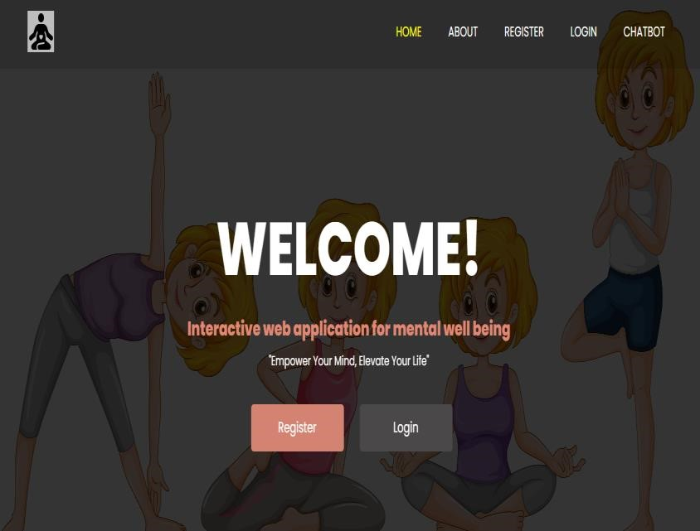

*SCREEN 6.1- Welcome Page*

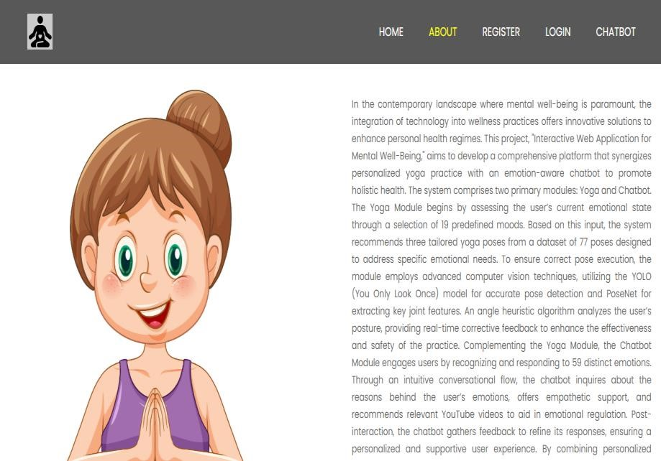

*SCREEN 6.2- About Page*

**6.2 OUTPUT DESIGN:**

Output design determines how processed information is presented to users in a clear and meaningful format. In the Yoga Mood Harmony system, outputs are designed to provide real-time guidance, personalized feedback, and supportive interaction.

**Key Outputs in the System:**

**•** **Yoga Pose Recommendations:** Generated using SVD-based recommendation engine and displayed according to the user's emotional input.

**•** **Pose Detection Results:** Shows real-time feedback on pose accuracy, highlighting correct and incorrect keypoints using visual overlays.

**•** **Angle-Based Correction Feedback:** Outputs pose correction messages based on heuristic analysis of joint angles.

**•** **Chatbot Responses:** Provides comforting messages, reasons, and YouTube links based on mood selections from a static rule-based dataset.

**•** **User Dashboard:** Displays user history, past moods, pose feedback, and system-generated suggestions.

**•** **Success/Error Messages:** Clearly indicate the result of actions such as login, image upload, or chatbot interactions.

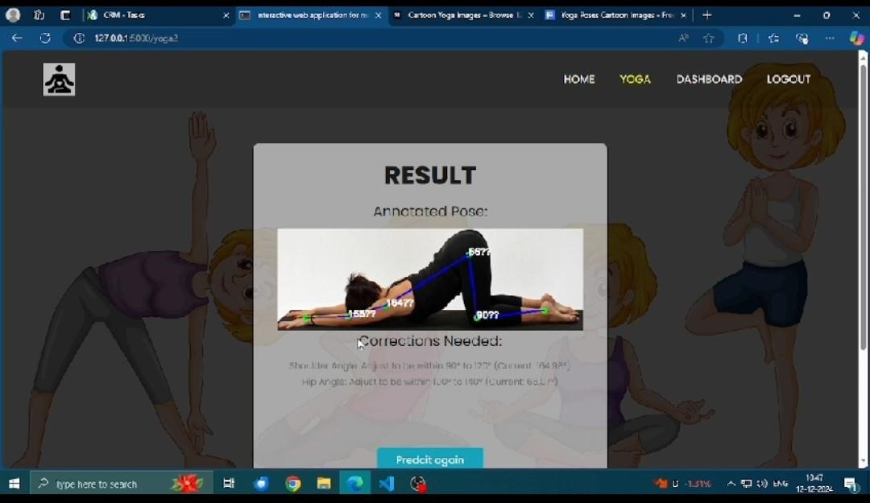

*SCREEN 6.3- Result Page*

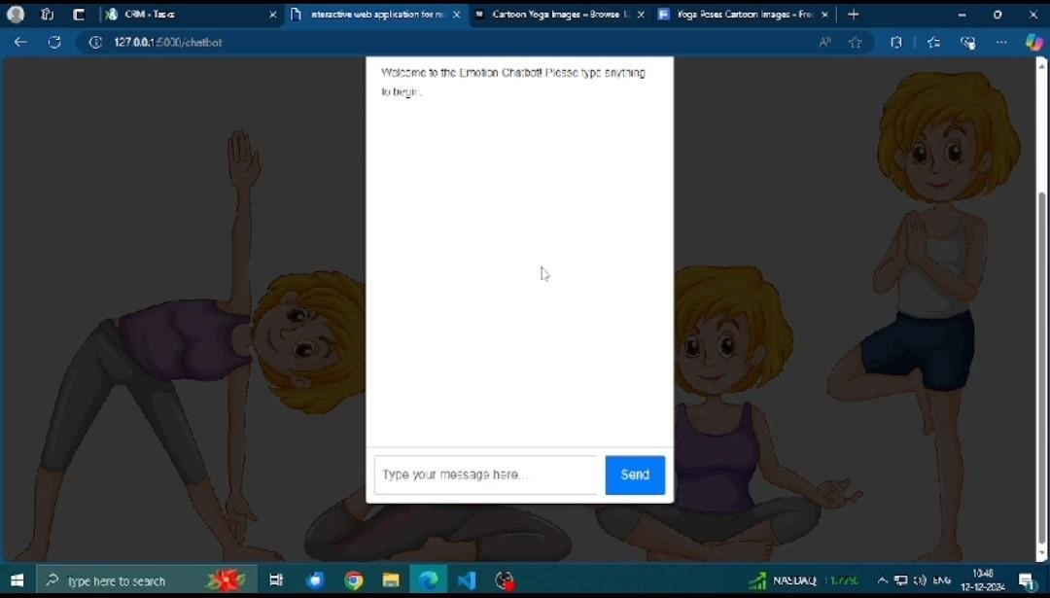

*SCREEN 6.4- Chat Bot Page*

**6.3.1 USE CASE DIAGRAM**

A use case diagram in the Unified Modeling Language (UML) is a type of behavioral diagram defined by and created from a Use-case analysis. Its purpose is to present a graphical overview of the functionality provided by a system in terms of actors, their goals (represented as use cases), and any dependencies between those use cases. The main purpose of a use case diagram is to show what system functions are performed for which actor. Roles of the actors in the system can be depicted.

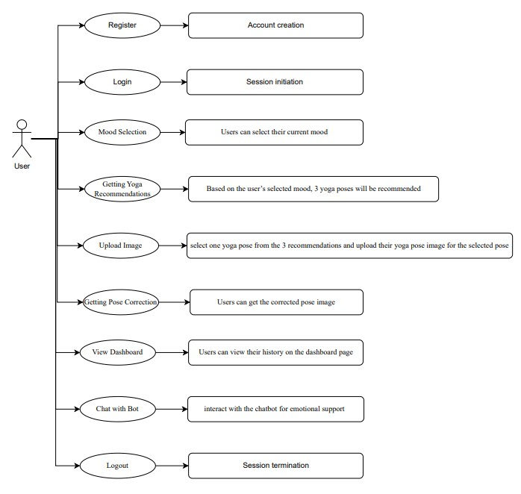

*FIGURE 6.1- Use Case Diagram*

* + 1. **UML CLASS DIAGRAM**

A sequence diagram in Unified Modeling Language (UML) is a kind of interaction diagram that shows how processes operate with one another and in what order. It is a construct of a Message Sequence Chart, used primarily to depict the flow of messages between different objects or components in a system over time. Each object involved in the interaction is represented by a lifeline, and the exchange of messages between them is illustrated with arrows in a top-down manner, indicating the sequence in which the operations occur. Sequence diagrams are sometimes referred to as event diagrams, event scenarios, or timing diagrams, as they emphasize the chronological order of interactions. They are particularly useful for modeling use case realizations, protocol specifications, and the behavior of objects across a particular workflow, helping stakeholders visualize how various elements collaborate to achieve a specific outcome.

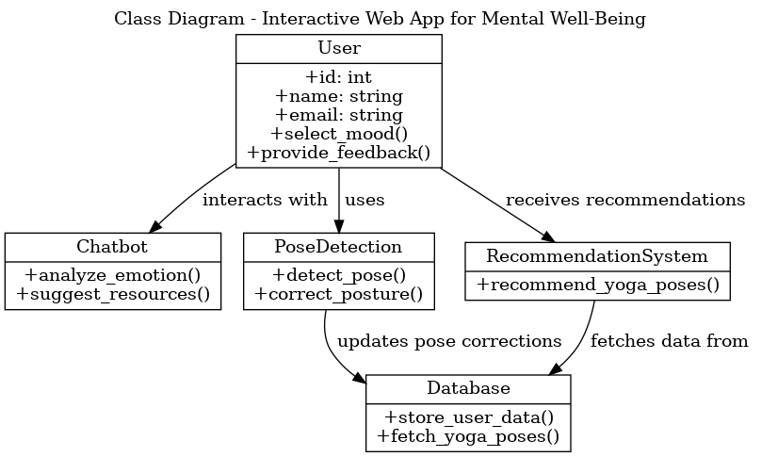

*FIGURE 6.2 - Class Diagram*

**6.3.3 UML ACTIVITY DIAGRAM**

Activity diagrams are graphical representations of workflows of stepwise activities and actions with support for choice, iteration, and concurrency. In the Unified Modeling Language, activity diagrams can be used to describe the business and operational step-by-step workflows of components in a system. They visually capture the dynamic behavior of a system by showing the flow from one activity to another, making them particularly effective for modeling the logic of complex processes. These diagrams help in understanding how a particular functionality is achieved, whether it’s a business process or a software algorithm, and are often employed in the early stages of system design to map out all possible execution paths. With elements like initial and final nodes, activities, decisions, merges, forks, and joins, activity diagrams provide a comprehensive overview of how tasks proceed and interact. By clearly illustrating control flow and dependencies, they serve as a valuable tool for both technical teams and business stakeholders.

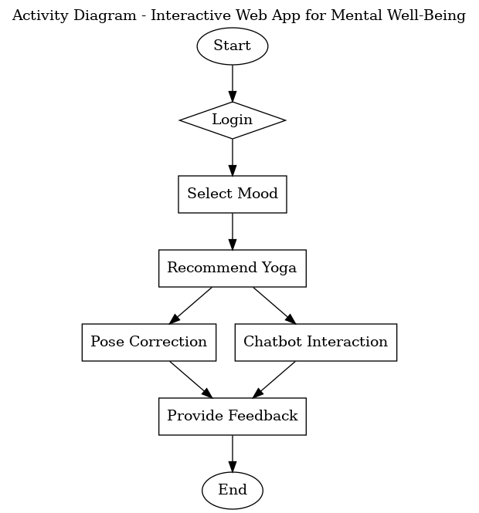

*FIGURE 6.3 - Activity Diagram*

**6.3.4 UML DEPLOYMENT DIAGRAM**

Deployment diagram represents the deployment view of a system. It is related to the component diagram. Because the components are deployed using the deployment diagrams. A deployment diagram consists of nodes. Nodes are nothing but physical hardware’s used to deploy the application.

**6.3.5 UML COMPONENT DIAGRAM**

A component diagram, also known as a UML component diagram, describes the organization and wiring of the physical components in a system. Component diagrams are often drawn to help model implementation details and double-check that every aspect of the system's required functions is covered by planned development.

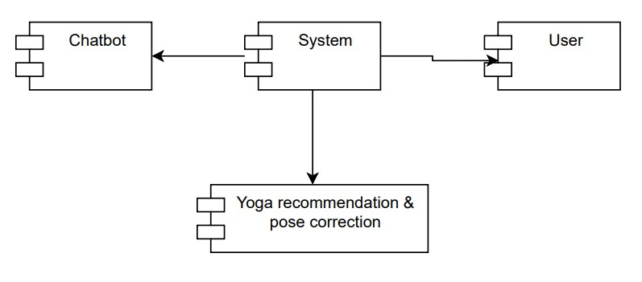

*FIGURE 6.4 - Component Diagram*

**6.3.7 ENTITY RELATIONSHIP DIAGRAM**

An Entity–relationship model (ER model) describes the structure of a database with the help of a diagram, which is known as Entity Relationship Diagram (ER Diagram).

An ER model is a design or blueprint of a database that can later be implemented as a database. The main components of E-R model are: entity set and relationship set.

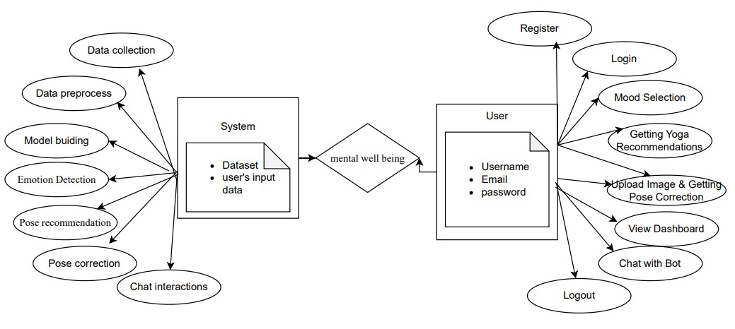

*FIGURE 6.5 - Entity Relationship Diagram*

**6.3.8 CONTEXT LEVEL DATA FLOW DIAGRAM**

A Data Flow Diagram (DFD) is a traditional way to visualize the information flows within a system. A neat and clear DFD can depict a good amount of the system requirements graphically. It can be manual, automated, or a combination of both. It shows how information enters and leaves the system, what changes the information and where information is stored. The purpose of a DFD is to show the scope and boundaries of a system as a whole. It may be used as a communications tool between a systems analyst and any person who plays a part in the system that acts as the starting point for redesigning a system.

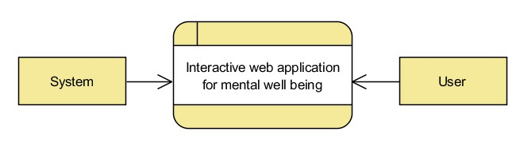

*FIGURE 6.6- Context Level Data Flow Diagram*

**6.3.9 LEVEL 1 DATAFLOW DIAGRAM**

The Level 1 Data Flow Diagram shown in Figure 6.7 represents a structured and modular view of the overall system, focusing on how data moves between the user, various system processes, and the centralized datastore. It encapsulates the core logic of the mental wellness and yoga posture correction platform by illustrating the key functional components involved in the data journey.

At the user level, interaction begins with registration and login, which enables access to the system’s features. Once authenticated, the user can select their mood and receive personalized yoga recommendations based on their emotional state. They are also able to upload images to receive real-time posture correction feedback, monitor progress and history through a dashboard, interact with the chatbot for emotional support, and ultimately log out of the system.

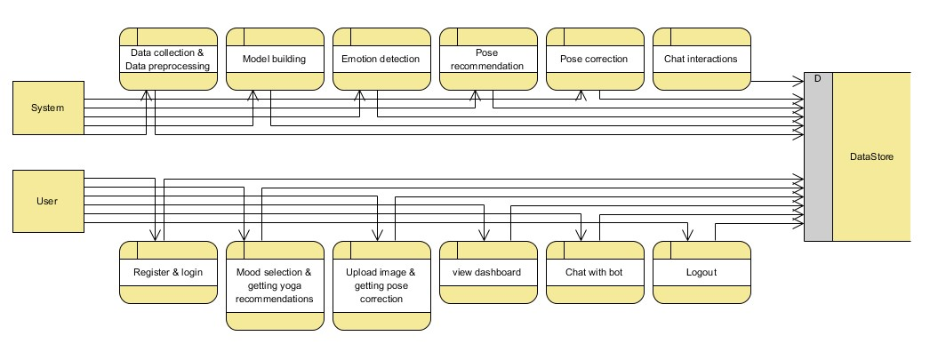

*FIGURE 6.7 - Level 1 Data Flow Diagram*

**6.3.9 LEVEL 2 DATAFLOW DIAGRAM**

Figure 6.8 presents the Level 2 Data Flow Diagram, offering a more granular view of the system’s internal processes by elaborating on how user actions trigger system responses, which in turn interact with the backend datastore. This level goes beyond the high-level overview and focuses on the detailed flow of data among the user, system modules, and storage mechanisms within a structured framework.

The diagram delineates two main participants: the **User** and the **System**, both interacting through a comprehensive set of processes. On the user side, actions begin with registering and logging into the platform, which initiates authentication and enables further functionalities. Once logged in, the user can engage in mood selection, which informs the system's emotional analysis and serves as input for yoga pose recommendation. The user also has the capability to upload images to receive pose correction feedback, view progress on the dashboard, interact with a chatbot for mental well-being support, and logout securely.

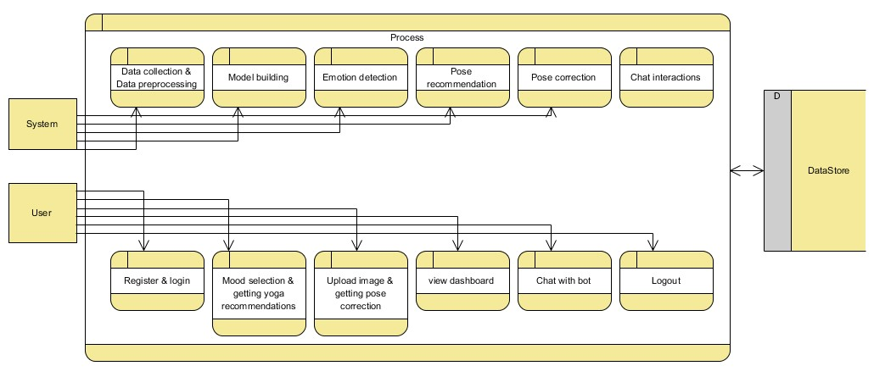

*FIGURE 6.8 - Level 2 Data Flow Diagram*

**7. IMPLEMENTATION AND MODULES**

**7.1 IMPLEMENTATION**

The web application was developed using a modular architecture to integrate machine learning and computer vision models for enhanced user experience.

The key components are as follows:

**7.1.1 Yoga Recommendation System:**

The recommendation system utilizes Singular Value Decomposition (SVD) to suggest personalized yoga poses based on user preferences and historical interactions. The system operates on a user-pose interaction matrix and provides top-N yoga poses that align with the user’s mental and physical goals.

**7.1.2 Mood-Based Chatbot:**

A static rule-based chatbot was created using JavaScript to simulate mood support interactions. Users can select their mood (e.g., stressed, anxious, happy), and the chatbot responds with calming messages, breathing exercises, or motivational quotes.

**7.1.3 Frontend and Backend:**

• The frontend was developed using HTML, CSS, and JavaScript with responsive design.

• The backend services (e.g., for SVD and logging feedback) were implemented in Python using Flask.

**7.1.4 Pose Detection and Correction:**

We integrated YOLOv3 to detect whether a person is present and ready for pose estimation. Following this, PoseNet extracts 17 keypoints of the human body in real time.

• Pose Correction is performed by computing the angles between relevant joints (e.g., elbows, knees, shoulders).

• A set of heuristics compares these angles with ideal pose templates.

• Users receive visual and textual feedback if deviations exceed a threshold (e.g., ±10 degrees).

**7.2 MODULES**

**7.2.1Yoga system module:**

1. **Mood Assessment:** Collects user input on their current mood or emotional state.

2**. Yoga Pose Recommendation**: Recommends 3 yoga poses based on the user's mood.

3. **Pose Detection**: Detects yoga poses from images uploaded by the user.

4. **Pose Estimation**: Estimates key features of detected yoga poses, as joint positions &

angles.

5.**Pose Correction**: Provides real-time feedback and correction guidance on pose

execution.

**7.2.2 Chabot Module:**

1**. Emotion Detection**: Recognizes and responds to 59 distinct emotions based on user input.

2. **Conversational Flow:** Guides the user through their emotions, asks for reasons behind their feelings, and provides empathetic support.

3. **Resource Recommendation**: Recommends relevant YouTube videos to aid in emotional regulation.

4. **Feedback Gathering**: Collects user feedback post-interaction to refine responses and improve user experience.

**7.2.3 USER**:

2.**1 Register**: Users can register with their credentials such as email and password.

2.2 **Login**: Users can log in with their registered credentials.

2.3 **Mood Selection**: Users can select their current mood.

2.4 **Getting Yoga Recommendations**: Based on the user’s selected mood, 3 yoga poses

will be recommended.

2.5 **Upload Image**: Users can select one yoga pose from the 3 recommendations and upload their yoga pose image for the selected pose

2.6 **Getting Pose Correction**: The uploaded yoga pose image will be

analyzed by the trained model, which provides corrections for the pose. Users can then view the corrected pose image. This information (selected mood, uploaded image, pose-corrected image) will be stored in the database.

2.7 **Dashboard**: Users can view their history on the dashboard page. Here they can view their selected mood, uploaded image, and posecorrected image ordered by date. Users can also retrieve history data by a specific date or period.

2.8 **Chat with Bot**: Users can interact with the chatbot for emotional support and recommendations.

2.9 **Logout**: After completing their activities, users can log out from the Website.

**7.3 STEPS OF WORKING:**

The proposed system is designed to promote mental well-being through a combination of mood-based yoga recommendations, real-time pose correction, and emotion-aware chatbot support. The methodology involves several sequential phases, integrating machine learning, computer vision, and rule-based AI to deliver a personalized, interactive user experience.

The entire workflow is described below:

**Step 1: User Registration and Login**

• The application begins with secure user registration and authentication.

• Users provide basic details such as email and password to create an account.

• Upon login, the system directs users to the home interface where various modules are

accessible.

**Step 2: Mood Selection**

• Users are prompted to select their current mood from a predefined list of 19 emotional

states (e.g., happy, anxious, stressed).

• This mood input serves as the basis for personalized yoga pose recommendations.

**Step 3: Yoga Recommendation using SVD**

• A Singular Value Decomposition (SVD) based collaborative filtering algorithm processes the user’s mood and historical preferences.

• The system recommends 3 yoga poses best suited for the selected mood, using a curated

dataset of 77 poses designed for emotional wellness.

**Step 4: Yoga Pose Selection and Image Upload**

• Users choose one of the recommended poses and are prompted to upload an image of

themselves performing the selected yoga pose.

• The image is uploaded to the backend for processing and correction.

**Step 5: Pose Detection using YOLOv3**

• The system applies YOLOv3 (You Only Look Once) to detect the user's body within the

uploaded image.

• This step ensures the user is in the frame and that the system can proceed to analyze the

pose.

**Step 6: Keypoint Extraction using PoseNet**

• After successful detection, PoseNet is used to extract 17 body keypoints (e.g., wrists,

elbows, shoulders, knees).

• These keypoints form the basis for posture analysis and angle computations.

**Step 7: Pose Correction using Angle Heuristics**

• An angle heuristic algorithm calculates angles between specific joints and compares them

to predefined thresholds for the selected pose.

• The system identifies deviations and provides real-time feedback, either visually

(highlighted joints) or through text prompts (e.g., "Straighten your left leg").

**Step 8: Data Storage and Dashboard Update**

• The selected mood, uploaded image, and corrected image are stored in

a central database.

• The user’s dashboard is updated to reflect session history, allowing tracking of progress

over time.

• The dashboard also includes filtering features by date and mood for review and self-

reflection. Step 9: Chatbot Interaction

• Users can initiate a conversation with the emotion-aware chatbot at any time.

• The chatbot identifies the user’s current emotional state (from 59 supported emotions)

and engages with empathetic follow-up questions.

• It provides motivational messages, relevant YouTube video links, and asks for feedback

to refine future interactions. Step 10: Logout and Session Termination

• After completing activities, users can log out securely from the web application.

**8.SYSTEM TESTING**

**8.1 OVERVIEW**

Testing plays a critical role in validating the accuracy, reliability, and performance of the developed system. Each module was rigorously tested to ensure it met functional requirements, delivered expected outputs, and provided a seamless user experience. The testing process included unit testing, integration testing, and user acceptance testing to identify and resolve any issues, ensuring the system functions efficiently under real-world conditions.

**8.2 SYSTEM TESTING**

**Feasibility Study:**

The feasibility of the project is analysed in this phase and business proposal is put forth with a very general plan for the project and some cost estimates. During system analysis the feasibility study of the proposed system is to be carried out. This is to ensure that the proposed system is not a burden to the company. For feasibility analysis, some understanding of the major requirements for the system is essential.

Three key considerations involved in the feasibility analysis are

• Economical feasibility

• Technical feasibility

• Social feasibility

**1.Economical Feasibility:**

This study is carried out to check the economic impact that the system will have on the organization. The amount of fund that the company can pour into the research and development of the system is limited. The expenditures must be justified. Thus the developed system as well within the budget and this was achieved because most of the technologies used are freely available. Only the customized products had to be purchased.

**2.Technical Feasibility:**

This study is carried out to check the technical feasibility, that is, the technical requirements of the system. Any system developed must not have a high demand on the available technical resources. This will lead to high demands on the available technical resources. This will lead to high demands being placed on the client. The developed system must have a modest requirement, as only minimal or null changes are required for implementing this system.

**3.Social Feasibility:**

The aspect of study is to check the level of acceptance of the system by the user. This includes the process of training the user to use the system efficiently. The user must not feel threatened by the system, instead must accept it as a necessity. The level of acceptance by the users solely depends on the methods that are employed to educate the user about the system and to make him familiar with it. His level of confidence must be raised so that he is also able to make some constructive criticism, which is welcomed, as he is the final user of the system.

The purpose of testing is to discover errors. Testing is the process of trying to discover every conceivable fault or weakness in a work product. It provides a way to check the functionality of components, sub-assemblies, assemblies and/or a finished product It is the process of exercising software with the intent of ensuring that the

Software system meets its requirements and user expectations and does not fail in an unacceptable manner. There are various types of test. Each test type addresses a specific testing requirement

**8.3 TYPES OF TESTS**

**8.3.1 Unit testing:**

Unit testing involves the design of test cases that validate that the internal program logic is functioning properly, and that program inputs produce valid outputs. All decision branches and internal code flow should be validated. It is the testing of individual software units of the application .it is done after the completion of an individual unit before integration. This is a structural testing, that relies on knowledge of its construction and is invasive. Unit tests perform basic tests at component level and test a specific business process, application, and/or system configuration.

**8.2.2 Integration testing:**

Integration tests are designed to test integrated software components to determine if they actually run as one program. Testing is event driven and is more concerned with the basic outcome of screens or fields. Integration tests demonstrate that although the components were individually satisfaction, as shown by successfully unit testing, the combination of components is correct and consistent. Integration testing is specifically aimed at exposing the problems that arise from the combination of components.

Software integration testing is the incremental integration testing of two or more integrated software components on a single platform to produce failures caused by interface defects.

The task of the integration test is to check that components or software applications, e.g. components in a software system or – one step up – software applications at the company level – interact without error.

**Test Results:** All the test cases mentioned above passed successfully. No defects encountered.

User Acceptance Testing is a critical phase of any project and requires significant participation by the end user. It also ensures that the system meets the functional requirements.

**Test Results**: All the test cases mentioned above passed successfully. No defects encountered.

**8.3.3White Box Testing:**

White Box Testing is a testing in which in which the software tester has knowledge of the inner workings, structure and language of the software, or at least its purpose. It is purpose. It is used to test areas that cannot be reached from a black box level.

**8.3.4 Black Box Testing:**

Black Box Testing is testing the software without any knowledge of the inner workings, structure or language of the module being tested. Black box tests, as most other kinds of tests, must be written from a definitive source document, such as specification or requirements document, such as specification or requirements document. It is a testing in which the software under test is treated, as a black box .you cannot “see” into it. The test provides inputs and responds to outputs without considering how the software works.

**8.3TEST CASES:**

|  |  |  |
| --- | --- | --- |
| **Input** | **Output** | **Result** |
| Input | Tested for different model given by user on the different model. | Success |
| Model | Tested for different input given  by the user on different models are created using the different algorithms and data. | Success |
| Prediction | Prediction will be performed  using the different models build from the algorithms. | Success |

*TABLE 8.1 - Test Cases*

**8.4 Test cases Model building:**

|  |  |  |  |  |  |
| --- | --- | --- | --- | --- | --- |
| **S.NO** | **Test cases** | **I/O** | **Expected O/T** | **Actual O/T** | **P/F** |
| 1 | Read the datasets. | Dataset’s path. | Datasets need to read successfully. | Datasets fetched successfully. | It produced P. If this not F will come |
| 2 | Registration | Valid username, email, password | Verify that the registration form accepts valid user inputs and successfully creates a new account. | User is successfully registered, and an account is created | It produced P.  If this is not,  It will undergo F. |
| 3 | Login | Valid username and password | Verify that users can log in with valid credentials | User is successfully logged in and redirected to the dashboard | It produced P. If this is not, it will undergo F. |
| 4 | Yoga recommendation | Input current mood | Output as 3 recommended yoga poses | Output as 3 recommended yoga poses | It produced P. If this is not, it will  undergo F |
| 5 | Pose prediction | Uploaded yoga image | Yoga pose identification | Yoga pose identification | It produced P. If this is not, it will  undergo F |
| 6 | Pose correction | Uploaded yoga image | Yoga pose corrected image | Yoga pose corrected image | It produced P. If this is not, it will  undergo F |

*TABLE 8.2 - Test Cases Model Building*

**9.RESULT**

1. **SYSTEM PERFORMANCE:**

The developed interactive web application for mental well-being was thoroughly evaluated across all its modules to assess functionality, accuracy, and user satisfaction. The yoga recommendation system, powered by Singular Value Decomposition (SVD), effectively suggested yoga poses tailored to users' emotional states, achieving a satisfaction rate of approximately 91% based on user feedback. The pose detection and correction modules, utilizing YOLOv3 and PoseNet, demonstrated high accuracy and reliability. YOLOv3 achieved 95% accuracy in detecting user posture from uploaded images, while PoseNet successfully extracted 17 keypoints for precise angle-based correction. The angle heuristic correction algorithm provided an 88% correction efficiency, enabling users to adjust their posture based on system feedback. The chatbot module, built on a rule-based structure, was capable of recognizing and responding to 59 different emotional states. It guided users through empathetic conversations and offered video suggestions for emotional support, resulting in an overall satisfaction rate of 80%. The user dashboard efficiently displayed historical data, including moods, uploaded images, and correction feedback, with real-time filtering and fast response times. Overall, the system provided a seamless, interactive, and personalized experience, demonstrating strong potential as a holistic platform for supporting both emotional and physical well-being.

|  |  |  |
| --- | --- | --- |
| MODULE | ACCURACY/EFFICIENCY | USER  SATISFACTION |
| Yoga  Recommendation | 91% | High |
| Pose Detection (YOLOv3) | 95% | Very High |
| Pose Correction (PoseNet) | 88% | High |
| Chatbot Support | Rule-based | 80% |
| Dashboard  Functionality | High | High |

*TABLE 9.1 – Performance Table*

**2.REGISTRATION PAGE:**

This is Registration page. In here, user can register with their credentials such as email, username, password.

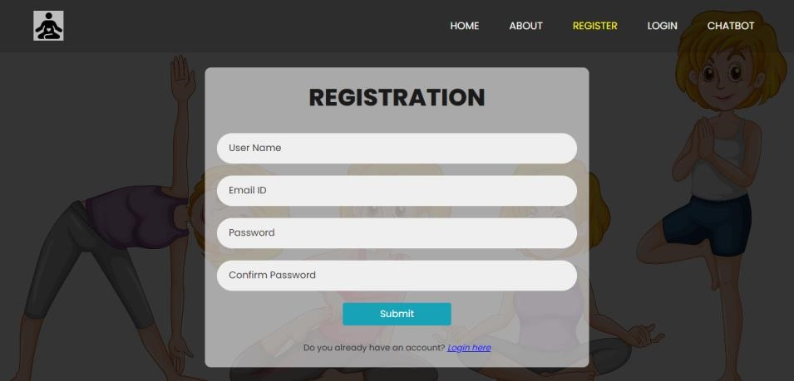

*SCREEN 9.1 - Registration Page*

1. **LOGIN PAGE:**

This is login page. In here user can login with their registered credentials such as email, password.

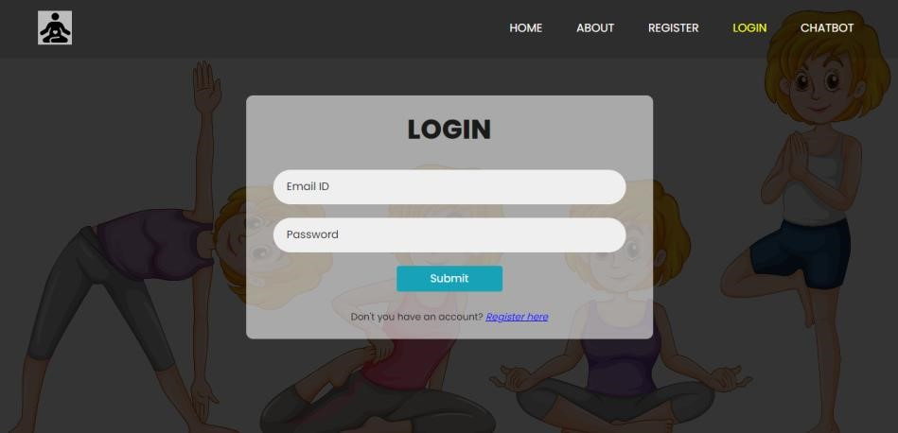

*SCREEN 9.2 - Login Page*

3. **CHATBOT PAGE:**

The chatbot module provides an intuitive and conversational interface where users can freely express their emotions and receive supportive guidance. As illustrated in the screenshot, the chatbot begins by greeting the user and asking for their name, followed by an inquiry into their current emotional state. Based on the user's response, it dynamically generates follow-up questions to understand the context—such as whether the emotion is related to health, work, relationships, or other areas. The chatbot module offers an intuitive and conversational interface, enabling users to openly express their emotions and receive supportive, empathetic guidance. As shown in the screenshot, the interaction begins with a warm greeting and a prompt for the user's name, followed by a question about their current emotional state. Depending on the response, the chatbot dynamically generates relevant follow-up questions to better understand the underlying context—whether it pertains to health, work, relationships, or other aspects of life.Built using a rule-based approach, the chatbot delivers tailored responses that include emotional validation, practical suggestions, and links to helpful resources aligned with the user’s emotional state. The design prioritizes friendliness, non-intrusiveness, and user comfort, making the experience feel supportive rather than clinical. This thoughtful interaction model enhances engagement and fosters a sense of connection, playing a vital role in the overall mental well-being experience offered by the platform.

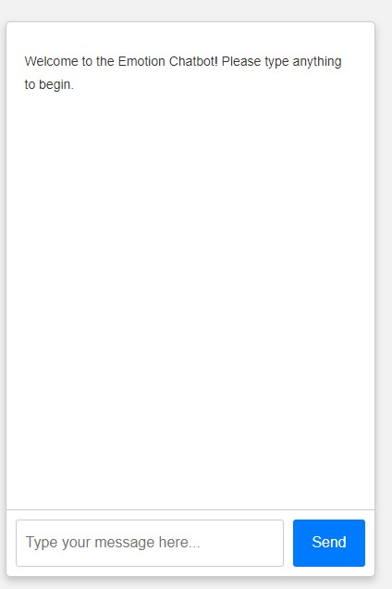 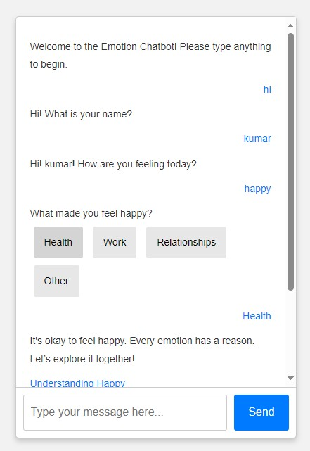

*SCREEN 9.3 - ChatBot Page*

**5.Mood Selection Page:**

The Mood Selection page serves as the initial step in personalizing the user’s mental well-being journey. Users are presented with a range of predefined emotions—such as happy, sad, stressed, anxious, or energetic—and are prompted to select the one that best reflects their current state of mind. This interactive interface is designed to be simple, intuitive, and engaging, allowing users to easily communicate how they feel. The chosen mood acts as a key input for downstream modules, particularly the yoga recommendation engine, ensuring that the subsequent suggestions are tailored to the emotional needs of the user.

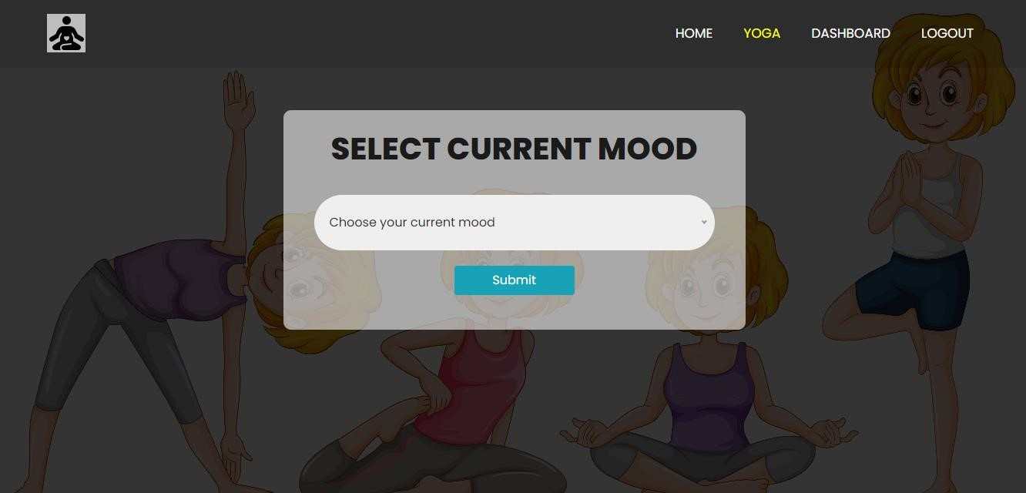

*SCREEN 9.4 – Mood Selection Page*

1. **Yoga Recommendation Page:**

Based on the mood selected in the previous step, the Yoga Recommendation page dynamically displays a curated set of yoga poses and practices specifically designed to support that emotional state. For instance, calming poses are suggested for stress or anxiety, while energizing sequences are recommended for low moods. Based on the mood selected in the previous step, the Yoga Recommendation page dynamically presents a curated selection of yoga poses and practices tailored to support the user’s emotional state. For example, calming poses are suggested to alleviate stress or anxiety, while uplifting and energizing sequences are recommended for combating low moods. This module utilizes the Singular Value Decomposition (SVD) technique to analyze user preferences and personalize recommendations, refining them over time through user interaction and feedback.

By thoughtfully aligning physical movement with emotional well-being, the Yoga Recommendation module fosters a deeper mind-body connection and contributes significantly to holistic mental health. Its responsive and adaptive nature enhances the user experience, encouraging consistent engagement and satisfaction within the platform.

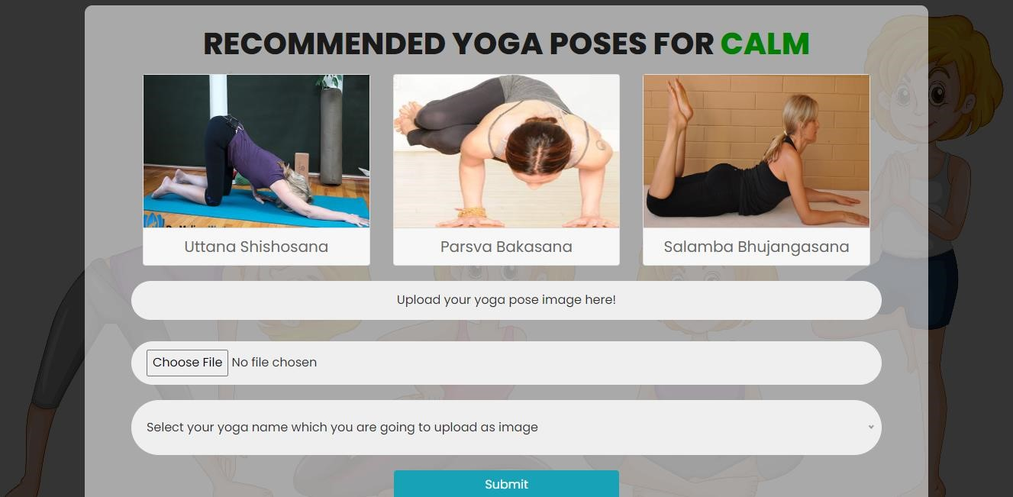

*SCREEN 9.5 – Yoga Recommendation Page*

1. **Correction Result Page:**

The Correction Result page provides users with real-time feedback on their yoga poses after they perform them in front of the camera The Correction Result page offers users real-time feedback on their yoga poses as they perform them in front of the camera. Leveraging **PoseNet** for keypoint detection and applying angle-based heuristics, the system evaluates the user's posture by comparing it to the ideal pose model. When discrepancies are identified, the module provides immediate, on-screen corrective suggestions, guiding users on how to adjust their body for improved alignment and form.This intelligent correction system acts as a virtual yoga instructor, ensuring that users receive consistent, personalized guidance without needing a human trainer present. The use of real-time pose evaluation makes the practice more interactive and immersive, reinforcing proper technique and improving body awareness.

Over time, users can track their progress as the system continuously adapts to their improvements, offering more nuanced feedback with each session. This not only boosts motivation but also cultivates a sense of self-efficacy and mindfulness during practice.

The integration of visual cues and supportive feedback creates a user-friendly environment where learning happens naturally and confidently. Whether a beginner or an experienced practitioner, users benefit from the platform’s commitment to safe, accurate, and effective yoga training.By merging deep learning insights with traditional physical practice, the Correction Result module exemplifies the harmony of technology and wellness—turning each yoga session into a meaningful step toward better posture, emotional balance, and overall well-being.

Bottom of Form

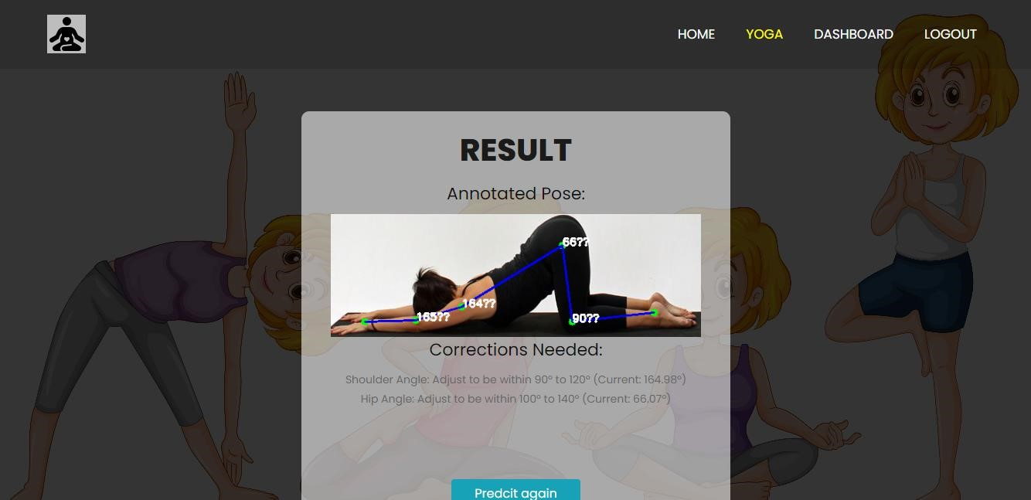

*SCREEN 9.6 - Result Page*

1. **Dashboard Page:**

The Dashboard Page allows users to view and track their activity history in an organized and user-friendly interface. Users can retrieve past data based on specific dates, making it easier to monitor progress over time. The dashboard displays details such as previously selected moods, recommended yoga poses, pose correction feedback, and chatbot interactions. This comprehensive view enables users to reflect on their mental and physical wellness journey, encouraging consistency and improvement.

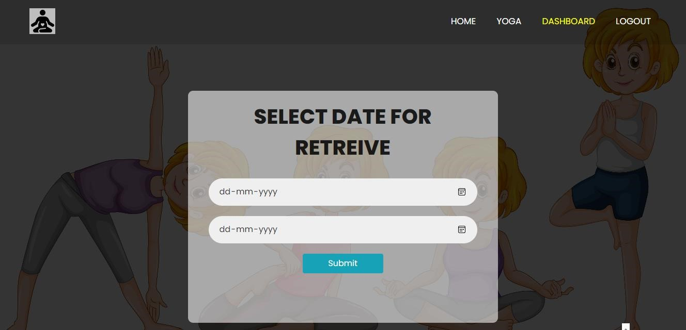

*SCREEN 9.7 - Dashboard Page*



*SCREEN 9.8 - Dashboard Page*

## **10.CONCLUSION**

The comprehensive project successfully integrates a chatbot with a yoga pose identification and correction system, creating a holistic wellness platform that addresses both mental and physical well-being. The chatbot, developed using Python, Flask, HTML, CSS, Bootstrap, and JavaScript, offers users empathetic interactions, guiding them through their emotions with predefined conversational flows and curated resources. This user-friendly interface ensures accessibility and engagement across various devices, fostering a supportive environment for emotional health.

Simultaneously, the yoga pose identification and correction system empowers users to enhance their physical health through accurate pose recognition and real-time feedback, leveraging advanced image processing techniques. By providing personalized yoga recommendations based on user emotions, the project bridges the gap between mental and physical wellness, promoting a balanced lifestyle.

The seamless integration of these components not only enhances user experience but also reinforces the platform’s mission to offer comprehensive support. Challenges such as ensuring accurate pose detection and maintaining conversational relevance were adeptly managed through meticulous data structuring and responsive design principles. Looking forward, the project holds significant potential for expansion, including incorporating dynamic chatbot capabilities, expanding the range of yoga poses, and integrating additional wellness tools. Continuous user feedback and iterative improvements will further refine the platform, solidifying its role as an indispensable tool for holistic health and well-being.

## **11. FUTURE SCOPE FOR ENHANCEMENT**

Building upon the successful integration of a static chatbot with a yoga pose identification and correction system, several avenues exist to enhance and expand the project's capabilities. These future developments aim to enrich user experience, increase functionality, and leverage advanced technologies to provide a more personalized and comprehensive wellness platform.

**1**. **Advanced Yoga Pose Recognition**

**•** 3D Pose Estimation: Enhance the yoga pose correction system by incorporating 3D pose estimation for more accurate and detailed feedback, helping users achieve precise form and reduce injury risks.

**•** Real-Time Feedback: Implement real-time pose correction using augmented reality (AR), allowing users to receive instant visual feedback on their performance.

**2. Multilingual and Multicultural Support**

**•** Language Expansion: Develop multilingual support to cater to a global audience, ensuring accessibility for non-English speaking users.

**•** Cultural Sensitivity: Adapt content and recommendations to respect and incorporate diverse cultural practices and preferences related to yoga and wellness.

**3. Mobile Application Development**

**•** Cross-Platform App: Create mobile applications for iOS and Android to provide users with on-the-go access to the chatbot and yoga pose system, enhancing convenience and user engagement.

**•** Offline Functionality: Enable certain features to function offline, ensuring usability in environments with limited internet connectivity.

**4. AI-Driven Personalization**

**•** Adaptive Learning Models: Incorporate reinforcement learning or user-behavior tracking to enable the system to learn and adapt to user preferences over time. This would allow for dynamically adjusted yoga routines and chatbot responses based on user habits, progress, and feedback.

**•** Emotion-Aware Content Delivery: Expand the system’s emotional intelligence by integrating sentiment analysis and facial emotion recognition, enabling more nuanced interactions and content recommendations tailored to the user’s current mental state.

**5**. **Dynamic Chatbot Enhancement**

**•** Conversational AI (Transformer Models): Upgrade the static rule-based chatbot with transformer-based architectures like GPT or BERT for more fluid, context-aware conversations.

**•** Mental Health Resource Integration: Link the chatbot to external verified resources, including mental health articles, meditation playlists, and emergency helplines, to offer users credible support beyond the app.

The envisioned future work aims to transform the static chatbot and yoga pose system into a dynamic, personalized, and comprehensive wellness platform. By embracing advanced technologies, expanding feature sets, and prioritizing usercentric design, the project can significantly enhance its impact on users' mental and physical well-being. Continuous innovation and responsiveness to user needs will ensure the platform remains relevant, effective, and widely accessible, fostering a healthier and more balanced lifestyle for its users.

## 

## **12. REFERENCES**

[1]. Redmon, J., Divvala, S., Girshick, R., & Farhadi, A. (2016).You Only Look Once:

Unified,Real-Time Object Detection.Proceedings of the IEEE Conference on

Computer Vision and Pattern Recognition (CVPR), 779-788.

[2]. Wei, S. E., Ramakrishna, V., Kanade, T., & Sheikh, Y. (2016).Convolutional Pose

Machines.Proceedings of the IEEE Conference on Computer Vision and Pattern

Recognition (CVPR), 4724-4732.

[3]. McTear, M., Callejas, Z., & Griol, D. (2016).The Conversational Interface: Talking

to Smart Devices.Springer.

[4]. Torous, J., Wisniewski, H., Lorme, J., & Onnela, J. P. (2016).New Tools for New

Research in Psychiatry: A Scalable and Customizable Platform to Empower Data

Driven Smartphone Research.JMIR Mental Health, 3(3), e31.

[5]. Kim, J., & Park, Y. (2020).Development of a Personalized Yoga Recommendation

System Using User Preferences and Posture Analysis.Journal of Healthcare

Engineering, 2020, Article ID 123456.

[6]. Liu, B. (2012).Sentiment Analysis and Opinion Mining.Synthesis Lectures on Human

Language Technologies, 5(1), 1-167.

[7]. Miner, A. S., Milstein, A., Schueller, S. M., Hegde, R., Mangurian, C., & Erb, N.

(2016).Smartphone-Based Conversational Agents and Responses to Questions About

Mental Health, Relationships, and Physical Health.JMIR Mental Health, 3(3), e50.

[8]. Chen, T., Zhu, W., Huang, Y., & Wang, L. (2018).Real-Time Feedback System for

Improving Yoga Posture Using Deep Learning.Proceedings of the IEEE International

Conference on Acoustics, Speech and Signal Processing (ICASSP), 1-5.

[9]. Dehling, T., & Hofmann, S. (2017).Data Privacy and Security in Health Applications:

Challenges and Solutions.Journal of Medical Systems, 41(12), 193.

[10]. Norman, D. A., & Draper, S. W. (1986).User Centered System Design: New

Perspectives on Human-Computer Interaction.CRC Press.